**Captured Signal**

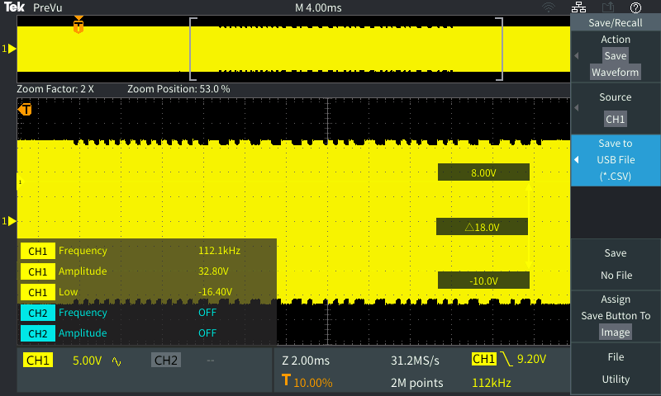

**Demodulated Data From Signal**

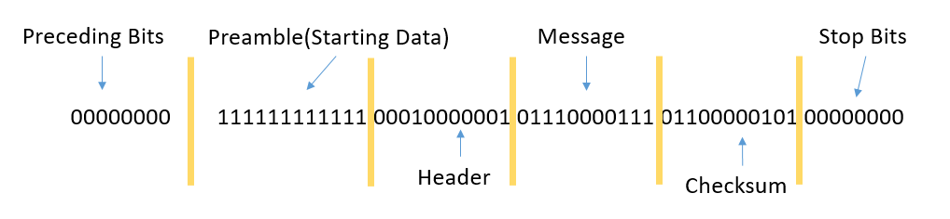

**Python Demodulation**

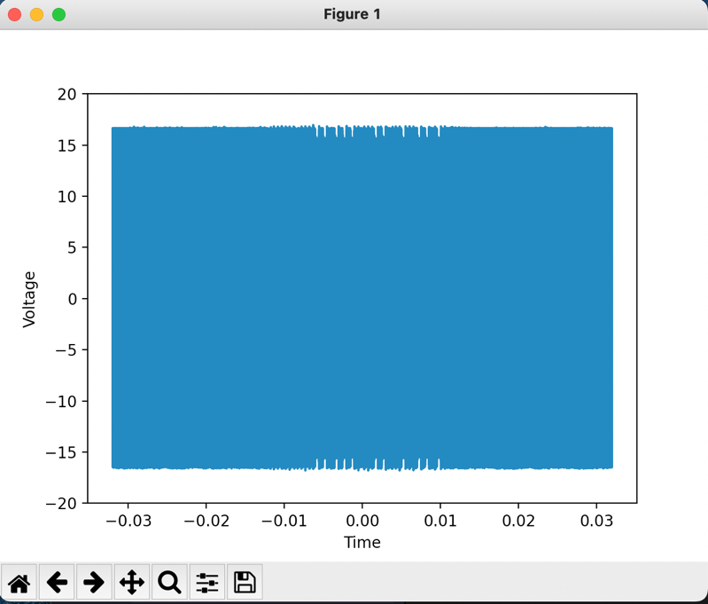**Part One (Graphing Signal)**: The first step was loading the csv file into python. For this, the csv library was used. Since not all the datapoints fit into a list, an offset constant was used to place every 10 datapoints into a list. Voltage was plotted on the y axis and time was plotted on the x axis.

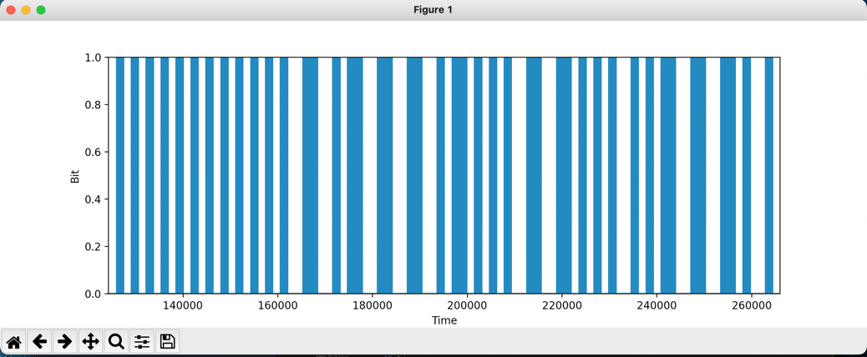**Part 2 (Graphing Bits):** From there, visual inspection of the previous graph was used to determine what time the message was received and what voltage values represented a one and a zero. Afterwards, a range of x-axis values was defined for the message and values above and below the threshold were changed to ones and zeroes respectively. From there, the new graph was plotted.

**Part 3 (Interpreting Results):** According to the structure of Qi packets, if the value changes from a 0 to a 1 during a cycle, that value is a one. If it stays constant during the full cycle, it’s a 0. This pattern was translated to code and the results of from the graph were translated into a Qi message.



**Part 4 (Code Generalization):** The code will be updated in the future to work more generally with all csv files that are input.